Exp 12. Demonstrate virtualization by Installing Type-2 Hypervisor in your device, create and

configure VM image with a Host Operating system (Either Windows/Linux), using VMware

workstation.

Step 1: Open VM ware and create a new virtual machine

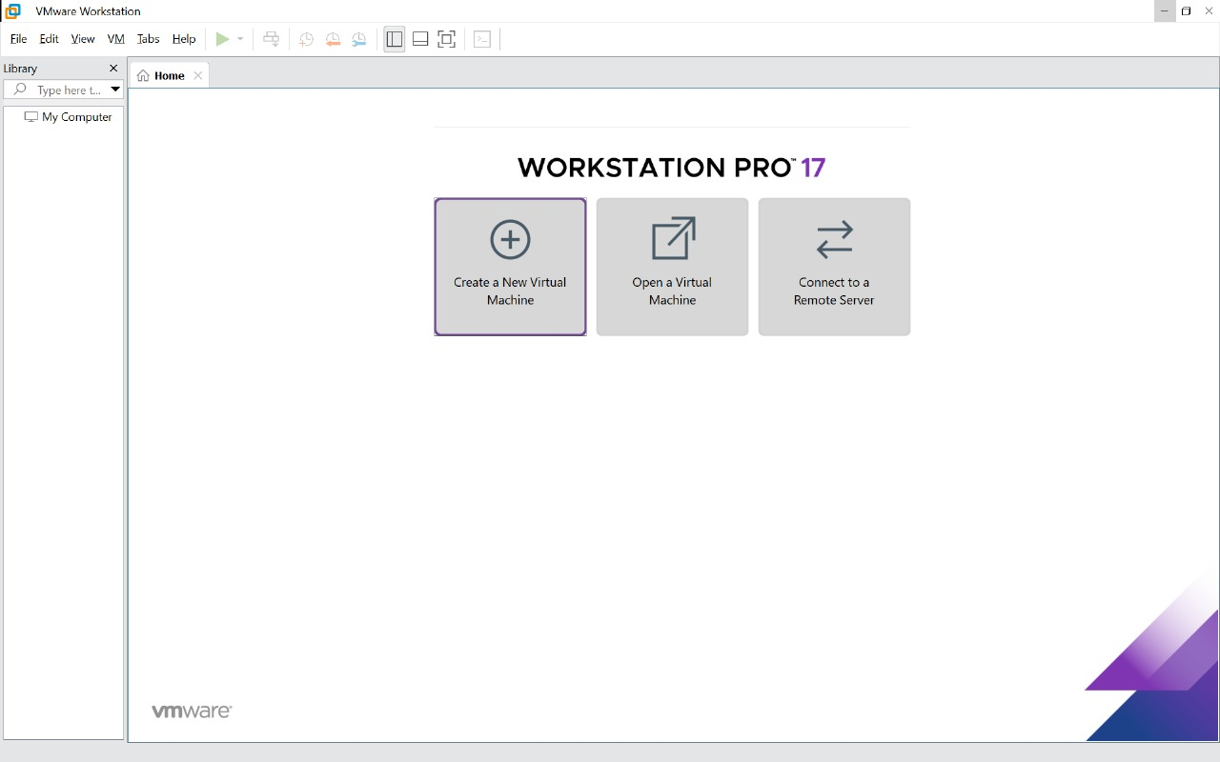

Step 2:

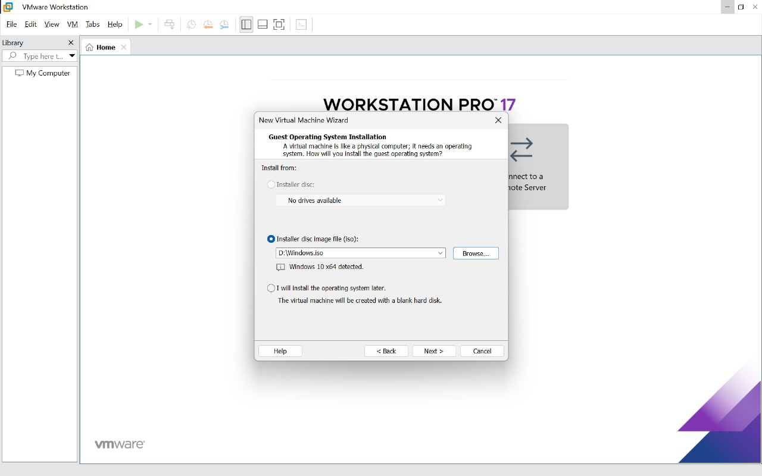

Step 3:

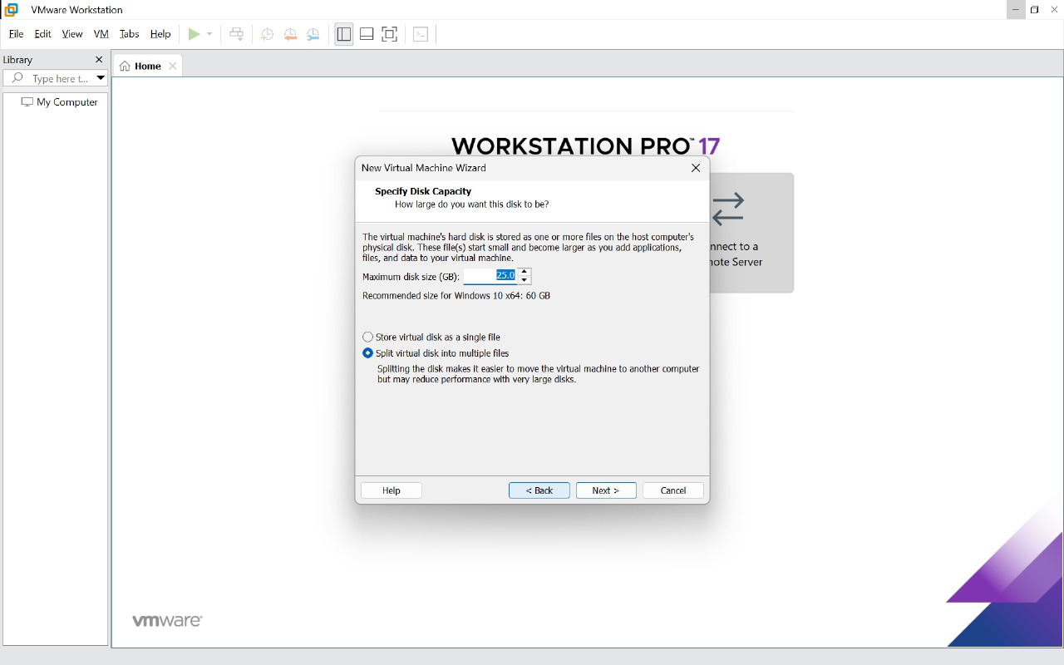

Step 4:

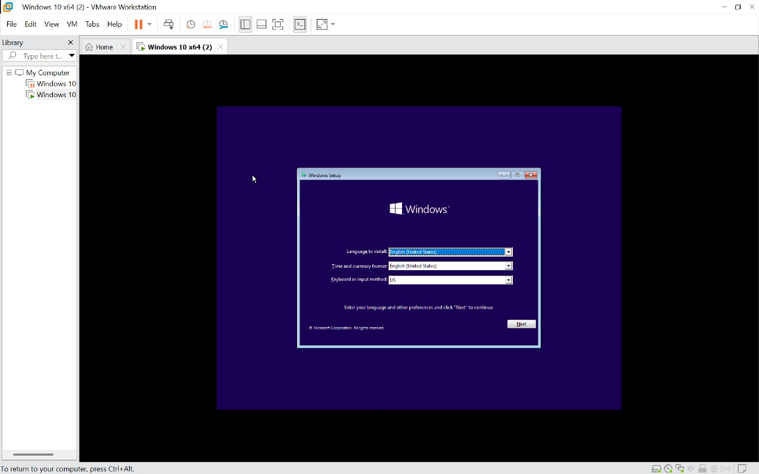

Step 5:

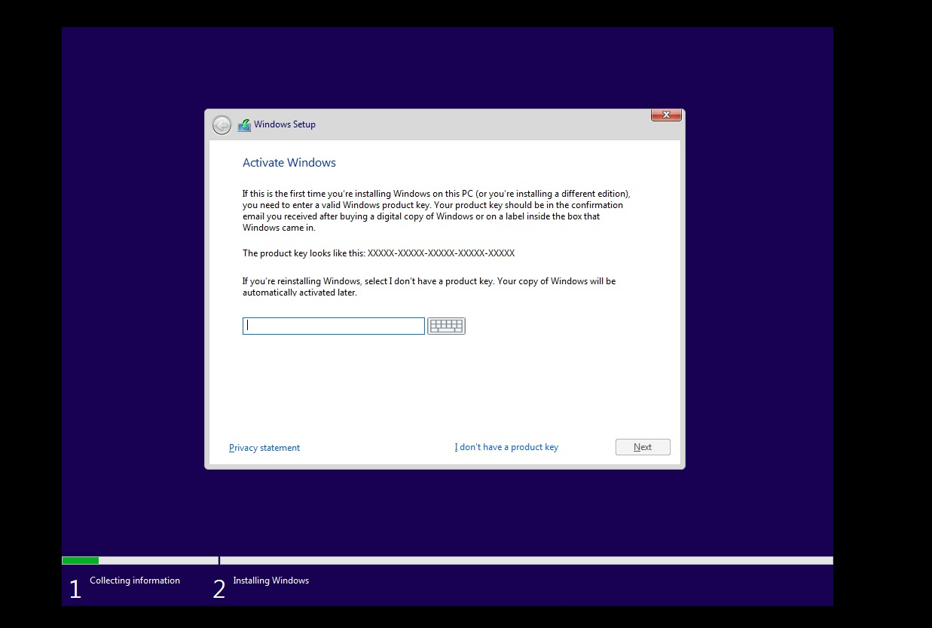

Step 6:

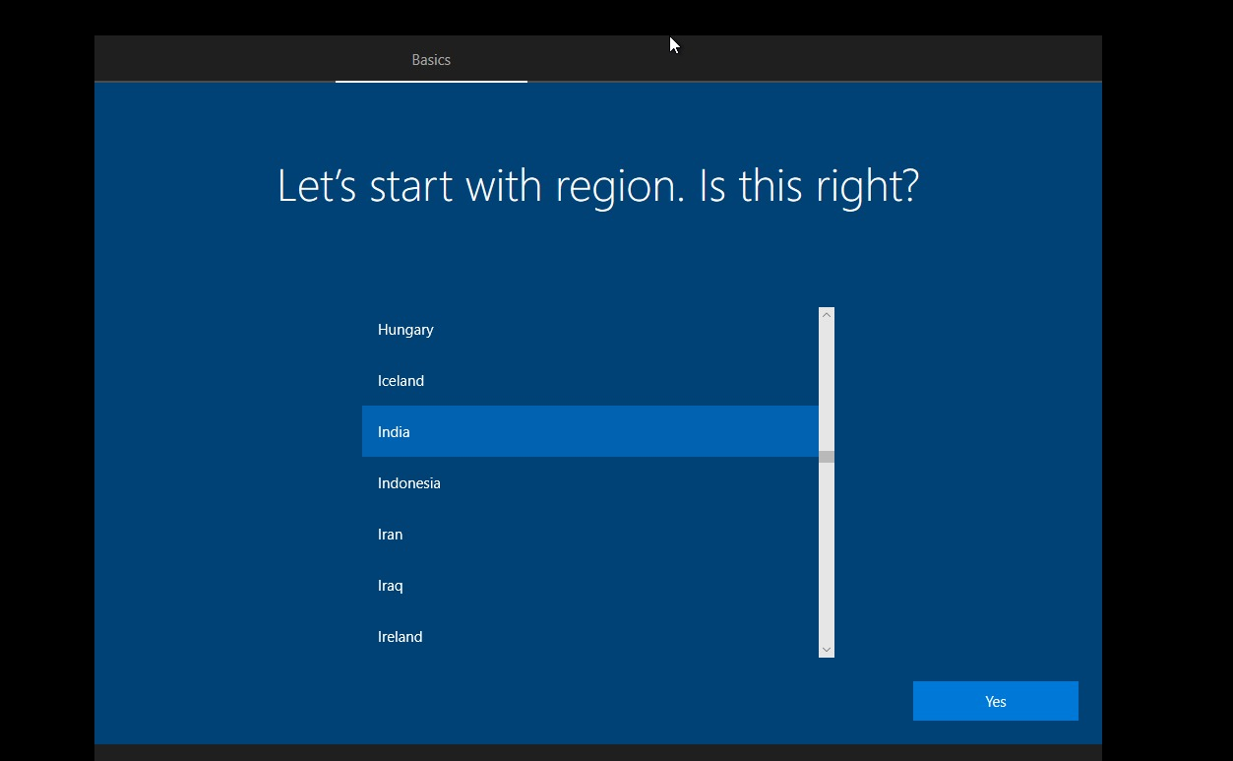

Step 7:

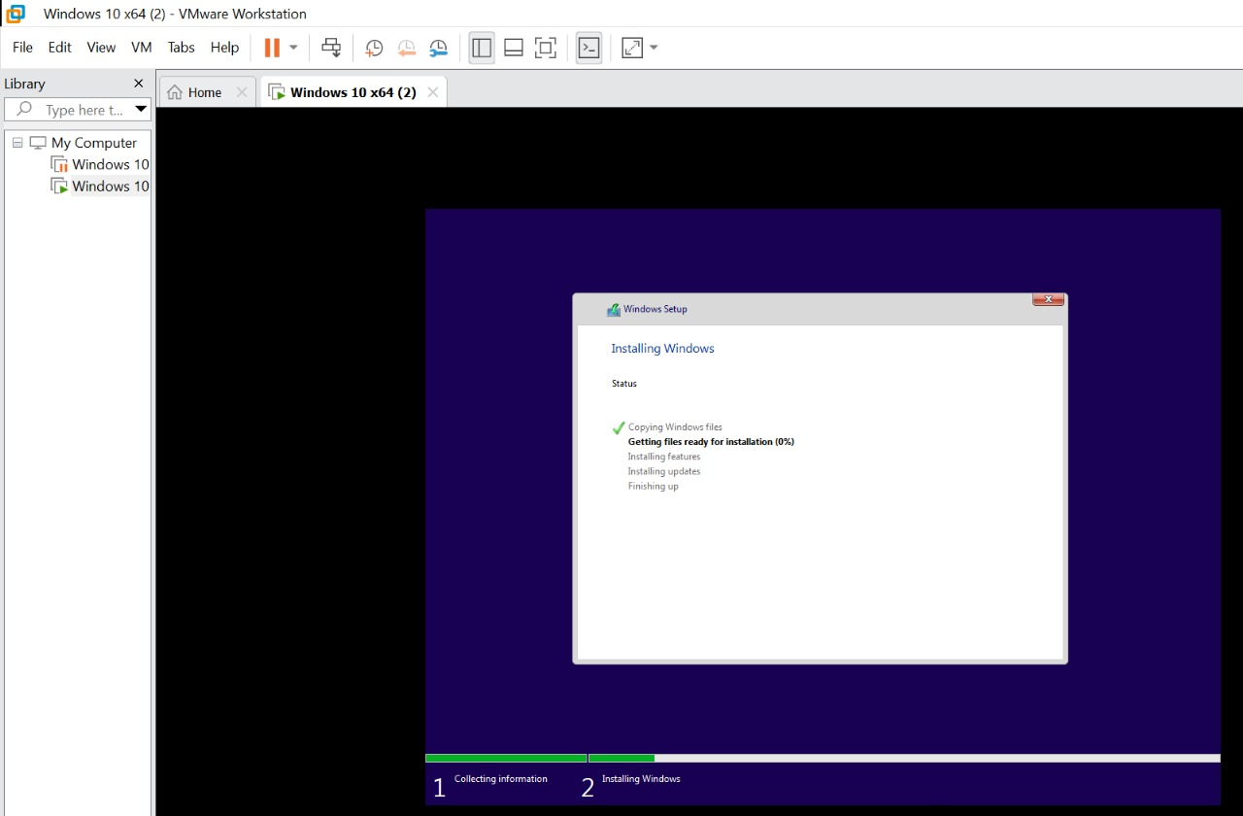

Step 8:

